Beyond the Card Shop: Invasion Sealed
Toby Wachter
Over the past few years Magic has evolved dramatically. Richard Garfield envisioned a game where you would constantly confront cards you had never seen before while playing. As you met new people and played against them, you could face entirely new strategies. Still, anyone who has been to a tournament can tell you this isn't the case. Decklists and card lists are constantly available, and the top decks in the format are widely known and copied.

How can a newer player gain level footing?
So how can a newer player gain level footing? How can someone who picked up his or her first starter a few months ago jump into the jungle of tournament play prepared? Beyond the Card Shop will break down advanced concepts to a basic level so that players of all abilities will advance their game. For veteran players, Beyond the Card Shop will reinforce old ideas and perhaps introduce a few new concepts.
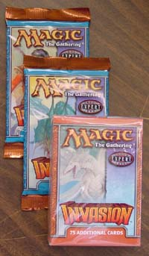
Since the current Pro Tour Qualifier season is Invasion Limited, what better place to start than with Sealed Deck? Limited has become a favorite of many, surpassing the popularity of Constructed in many areas. It is especially good for beginners. You don't need to worry about being crushed by some horribly broken combo deck, nor are you at a disadvantage for not having all the rares your deck needs. More importantly, Limited involves plenty of creature combat and player interaction, which will help you hone your skills. Any beginner can open up an amazing deck and make top 8 if basic playing and deckbuilding skills are present. Limited also increases your card pool for building Constructed decks.

Mike Long recently posted a great article about Sealed Deck. He describes the different types of cards for Sealed, and explains which ones are good and why. From here, we can jump directly into deck construction. Keep in mind that many of the fundamentals of Sealed Deck changed because of Invasion. Whereas before a four or five color deck was unheard of, it can now be an advantage. Invasion rewards you for being diverse in your colors, and gives you plenty of ways to keep your mana consistent. Just keep in mind that building a sealed deck in Invasion is much different than with other sets, where two or three colors is the norm.

Getting Started
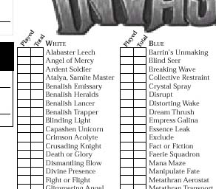
When a qualifier begins, you will receive a deck registration sheet. A common mistake most new players make is to fill this out quickly. You should take this very seriously, as an error can result in penalties. Line up every color in alphabetical order and mark them off. Then make sure to double-check what you wrote down. This may seem obvious, but many players have been taken out of contention in later rounds due to registering errors.
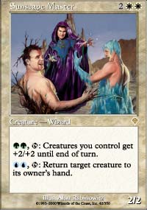
First, check for broken rares
After doing that, you will get a deck (sometimes it will even be the one you registered). Take a glance at all the cards in your deck to see if you got any broken cards that can carry you through the swiss portion of the tournament. Now that you've checked for broken rares, it's time to get down to business.
Then, take out the cards that never make the cut
The first thing you'll want to do is put all the bad cards into one pile. It will help to think easier without so many cards cluttering up the table. Cards that will rarely have an impact on the game fit into this category. Cards such as Wandering Stream, Mana Maze and Holy Day might fit into your deck later, but we're hoping for better stuff. Leave them in the cheerleader pile for now... it's not like they're being thrown away.
Now that we've separated the chaff, we can begin analyzing by color. Make a pile for each color, and line the cards on top of each other so you can at least see the names of all of them. Gold and Split cards can be put in a separate pile, or even between their colors. By laying out the contents, you can see exactly what tools are available to work with.
It is important to note the characteristics of each color in Invasion so they can be analyzed better. Here is a brief rundown so you know what to expect.

Green
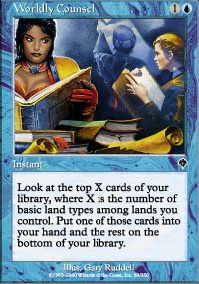
Green makes the Domain mechanic powerful
This color is the glue of the format. So many cards in Invasion become better when you play multiple colors, and Green is the color that lets you do it. Harrow, Quirion Trailblazer, Quirion Elves, Elfhame Sanctuary, Fertile Ground, Nomadic Elf and Quirion Sentinel all allow you to play a four or five color deck with ease. Whether the task is to get out more land to make cards such as Worldy Council more efficient or to get that extra land to use an Apprentice's other ability, Green can get it done.
The ability to have a stable multi-color base is incredible in this format. Color interaction is the main theme of Invasion, and Green is the only way to consistently build a five color deck. More importantly, by expanding your options into more colors, your card pool becomes deeper. This allows your deck to be stronger, as you have more options.
This would be enough by itself, but Green has the added benefit of having some of the best common creatures in the set. Kavu Climber, Pincer Spider, Serpentine Kavu and Thornscape Apprentice are usually automatic inclusions for your deck. Green also has its share of great uncommon and rare creatures such as Kavu Chameleon and the Juzam-like Jade Leech. Green creatures tend to be huge - and should dominate the board.

White
Even at first glance, it becomes obvious that White's major characteristic in this set are the creatures that can tap any creature as long as you give them a white mana. Benalish Trapper is right at home with a white casting cost, while Thornscape and Stormscape Apprentice are in different colors but require white to use. Opening up multiples of these can make your deck into quite an annoyance for your opponents. You tap opposing creatures, which prevents them from attacking, and as an added benefit, the way is cleared for your creatures. All sorts of tricks can be used with these guys, like tapping a creature on your opponent's end step, then one on your turn and attacking without having to worry about blockers.

White likes to tap things...
It is this strategy which makes white a color that is usually splashed. It won't be your main color, but it is a great supplement. This is especially applicable to the common gold spells white supports.
Armadillo Cloak is one of the most powerful creature enchantments to come out in a long time, and Wings of Hope is strong, too. Both of these cards require a white to be played, so you may put these in your deck along with other splashable cards such as Razorfoot Griffin and Shackles. White wants to tie the game up and buy you time.

Blue
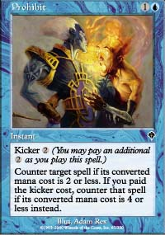
Kicker isn't part of a spell's mana cost...
Typically Blue is the forgotten child in Limited. It doesn't have the removal of red or black, the creatures of green or the tricks of white. This set is no exception, but Blue still gets its share of subtle cards that seem innocent enough but can swing games in your favor. Exclude and Repulse give you an indirect form of creature control, but the added bonus of drawing a card makes them incredibly powerful. Prohibit is a strange counterspell, but it has its tricks to it as well. It can be used to counter a Faerie Squadron, Duskwalker or Kavu Titan even when kicker is paid, since the kicker is not a part of the actual casting cost. Traveler's Cloak is also a great enchant creature as it replaces itself and makes one of your creatures unblockable.
Blue is not without its share of decent creatures either. Faerie Squadron is a big flyer in a set that usually dominates the air. Often, Faerie Squadron will attack without being bothered, and most flyers that can block it won't survive combat. Dream Thrush seems innocent enough, but it gives you multi-color support in a color that typically would have problems with it. Other strong uncommons and rares such as Fact of Fiction, Wash Out and Breaking Wave will lean you towards playing Blue.

Black
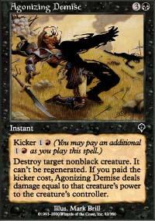
As always, the main drawing power of Black is its Terror type spells. You really can't go wrong with a card that can kill any non-black creature. Your primary spell of this type is Agonizing Demise. Annihilate is somewhat better, although uncommon so you won't get it as often. Exotic Curse is also a form of removal, although not as direct. It often does the job, though. Soul Burn is also a way to kill off critters, although more versatile. Not only can it remove creatures, but it can gain you life. Of course, the most popular use of the card is to send it directly towards your opponent to win the game. This card and others such as Plague Spores and Cinder Shade work best when you play red as support.
The creature base is solid, but nothing extraordinary. Duskwalker, Phyrexian Slayer and Phyrexian Reaper are fairly costed, with useful abilities. Ravenous Rats is an old favorite that can give you card advantage in a subtle way. Firescreamer is yet another card that becomes incredible when you play red. Black also has its share of the usual broken rare and uncommon creatures such as Tsabo's Assassin, Phyrexian Delver and Phrexian Infiltrator.

Red
As previously stated, red works best when used along with black. Still, it has an impressive share of removal. Tribal Flames is flat out unfair in a five color deck where it is capable of dealing five damage for only two mana. Scorching Lava and Zap are also incredible removal spells that can target the opponent for those last few points of damage. Red also has plenty of ways to throw fire around in the uncommon and rare slots. Breath of Darigaaz is absolutely amazing, allowing you to clear the board of most creatures. Dealing damage is great in itself, but with this card, it becomes a convenient side effect.

Getting a rare Ghitu Fire gives you a massive edge
Ghitu Fire is almost always worth playing, even if you weren't going to play red, as it can deal incredible amounts of damage to your opponent, making the job easier for your creatures. In older base set Limited environments, the decks with multiple Fireballs and Disintegrates always had the advantage, so getting a rare Ghitu Fire gives you a massive edge. Obliterate is also a great Limited card, clearing the board when you find yourself in a bad situation.
Red also has a decent selection of creatures. Ancient Kavu, Hooded Kavu, Kavu Aggressor and Pouncing Kavu don't have many flashy abilities, but they are well costed and good on offense. The uncommon and rare slots give us such gems as Skizzik, Halam Djinn and Kavu Monarch. Overall, the creatures are nothing amazing, but solid enough when supported by red's removal.
During deckbuilding, there will usually be one color will stand out right away as being superior. There are a number of factors that influence this. The color may have one or two incredibly broken cards that swing the game dramatically, such as Rout or Fact or Fiction. Other times it will contain an incredible amount of removal or a very strong creature base. Once you can identify color strengths, the deck can be built around that color. You will use other colors to magnify the primary color's strengths, and to cover up its weaknesses.
In tomorrow's article, we will finish looking at deckbuilding. This includes knowing which cards to cut from the deck, and why. Beyond that, we will look at how to play Limited, as it is a hard format to master regardless of the basic nature of the cards. Even though Constructed may be played with well tuned machines, Limited requires more thought because it involves working with less refined instruments.

